Prediction of Malignant and Benign Masses Using Machine Learning

Jeremiah M Hansen

Student ID: 010761841

Western Governors University

Table of Contents

A. Project Highlights 4

B. Project Execution 7

C. Data Collection Process 11

C.1 Advantages and Limitations of Data Set 12

D. Data Extraction and Preparation 12

E. Data Analysis Process 13

E.1 Data Analysis Methods 13

E.2 Advantages and Limitations of Tools and Techniques 14

E.3 Application of Analytical Methods 16

F Data Analysis Results 17

F.1 Statistical Significance 17

F.2 Practical Significance 18

F.3 Overall Success 19

G. Conclusion 19

G.1 Summary of Conclusions 19

G.2 Effective Storytelling 20

G.3 Recommended Courses of Action 21

H Panopto Presentation 9

References 23

Appendix A 24

Project Code 24

Appendix B 33

Link to Dataset 33

Appendix C 34

KDE Histograms of Dataset 34

Appendix D 47

Pair Plot/Scatter Plot of Dataset 16



Appendix E………………………………………………………………………………………………..48

Timeline and Milestones…………………………………………………………………………………..48

# A. Project Highlights

Are radiologic measurements a reliable source for predicting malignancy using machine learning models? The early and accurate detection of malignant masses is crucial for effective treatment and improved patient outcomes. This proposal aims to explore the feasibility of using machine learning (ML) models to predict whether a mass is malignant or benign based on data consisting of measurements of the mass in question.

The deliverables for the research question stated will include:

* A trained model that can be used to predict if a tumor is benign or malignant based on radiologic measurements.
* A Jupyter notebook that shows all exploratory data analysis that will go into picking the best model.
  + The Juypter notebook will include KDE Histogram Plots and Pair Plot/ Scatter Plot diagrams to analyze the data.
* A machine learning pipeline that:
  + Loads the data.
  + Preprocesses the data.
  + Splits the dataset.
  + Trains the model.
  + Evaluates the model.
* A requirements.txt file to allow the user to create the same environment used to create the ML pipeline locally.
* A readme file to explain how to use the ML pipeline.

**Included in Project Scope**

* The project will include analyzing and cleaning the dataset to ensure data quality and accuracy.
* Performance assessment of three machine learning algorithms: Support Vector Machine (SVM), logistic regression, and random forest classifier, to identify the most suitable model for data classification.
* Implementation of logistic regression as the chosen model due to its low complexity and high accuracy score.
* Validation and documentation of the logistic regression model's effectiveness, including accuracy metrics and complexity considerations.
* Development and release of a machine learning pipeline that automates the data processing and predictive modeling.
* Creation of detailed reports, performance comparison charts, model code, and comprehensive documentation for the project.
* A demonstration or presentation showcasing the machine learning pipeline's predictive capabilities.

**Not included in Project Scope**

* The project will not include the use of deep learning algorithms such as neural networks.
* It will not encompass any real-time data processing or live deployment of the machine learning model, focusing instead on static data analysis and classification.
* The project will not cover extensive hyperparameter tuning or optimization beyond the initial selection process.

**Tools, Environments, and Methodologies Overview**

1. **Standard Methodology:**

* The process of initiating, planning, executing, monitoring, controlling, and closing. Used for project management.
* The process for this project was tailored by changing the phases to establishing business understanding, exploring the data for understanding, data preparation, modeling, evaluating, and deployment.

1. **Hardware**:
   1. **High-Performance Workstation**: Essential for data processing, model training, and development of the machine learning pipeline.
2. **Software and Environments**:
   1. **Python**: The primary programming language for data analysis, model implementation, and pipeline development.
   2. **Scikit-learn**: A machine learning library in Python used for implementing and evaluating various models, including logistic regression, SVM, and random forest classifier.
   3. **Pandas**: A Python library for data manipulation and analysis, crucial for cleaning and preparing the dataset.
   4. **Jupyter Notebook**: An open-source web application for creating and sharing documents containing live code, equations, visualizations, and narrative text.
   5. **Matplotlib**: A Python library for data visualization, essential for creating performance comparison charts and other visual aids.
   6. **Seaborn**: A Python library built on top of Matplotlib, used for statistical data visualization.
   7. **Argparse**: A Python library for parsing command-line arguments.
   8. **Virtualenv**: A tool for creating isolated Python environments, ensuring that the project's dependencies are managed and maintained separately.
   9. **Visual Studio Code**: An integrated development environment (IDE) for writing, debugging, and managing Python code, providing a convenient and efficient workspace for development.

# B. Project Execution

**Project Plan**

* Goal: The goal of this project is to develop a machine learning model that accurately classifies data using logistic regression due to its low complexity and high accuracy score.
  + Objective 1.1: Assess the performance of different machine learning algorithms (SVM, logistic regression, random forest classifier) on the dataset.
    - Deliverable 1.1.1: A detailed report summarizing the data analysis and cleaning process.
* Deliverable 1.1.2: A performance comparison chart of SVM, logistic regression, and random forest classifier algorithms.
  + Objective 1.2: Implement logistic regression as the chosen model for data classification.
* Deliverable 1.2.1: The implemented logistic regression model code.
* Deliverable 1.2.2: A summary document explaining why logistic regression was chosen, including the accuracy score and complexity considerations.
  + Objective 1.3: Validate and document the effectiveness of the logistic regression model.
* Deliverable 1.3.1: Validation results with accuracy metrics.
* Deliverable 1.3.2: A final report documenting the project's goals, objectives, methods, and results.
  + Objective 1.4: Develop and release a machine learning pipeline that automates data processing and predictive modeling.
* Deliverable 1.4.1: A fully functional machine learning pipeline that includes data preprocessing, model training, and prediction.
* Deliverable 1.4.2: Documentation for the machine learning pipeline, including setup instructions and usage guidelines.
* Deliverable 1.4.3: A demonstration or presentation showcasing the pipeline's predictive capabilities.

**Variance**

Upon completion of each objective, there was no variance between what was planned and what was delivered.

**Planning Methodology**

## Standard Methodology

**Phase 1: Business Understanding**

* Step: Define the project objectives and requirements.
  + Actions: Understand the dataset, set the goal to develop a machine learning model with logistic regression, and determine the scope. (GeeksforGeeks, 2023)

**Phase 2: Data Understanding**

* Step: Gather and explore the data.
  + Actions: Analyze and clean the dataset to ensure data quality, understand the variables and their relationships, and prepare initial reports on data insights. (GeeksforGeeks, 2023)

**Phase 3: Data Preparation**

* Step: Preprocess and transform the data.
  + Actions: Clean the dataset, handle missing values, and prepare the data for machine learning algorithms (SVM, logistic regression, random forest classifier). (GeeksforGeeks, 2023)

**Phase 4: Modeling**

* Step: Select and apply modeling techniques.
  + Actions: Test SVM, logistic regression, and random forest classifier algorithms on the cleaned dataset. Implement logistic regression as the chosen model based on its performance and complexity (GeeksforGeeks, 2023).

**Phase 5: Evaluation**

* Step: Assess the model's effectiveness.
  + Actions: Validate the logistic regression model, compare its performance with other algorithms, and document accuracy metrics. Prepare validation results and a final project report. (GeeksforGeeks, 2023)

**Phase 6: Deployment**

* Step: Implement the model in a practical application.
  + Actions: Develop and release a machine learning pipeline that automates data processing and predictive modeling. Create documentation, setup instructions, and conduct a demonstration of the pipeline's predictive capabilities. (GeeksforGeeks, 2023)

**Variance**

Upon completion of the planning methodology, there was no variance between what was planned and what was performed.

## Timeline and Milestones

|  |  |  |  |
| --- | --- | --- | --- |
| **Milestone** | **Duration** | **Projected Start Date** | **Projected End Date** |
| Analyze and clean dataset (Objective 1.1.1) | 2 days | 02-03-2025 | 02-05-2025 |
| Performance comparison (Objective 1.1.2) | 1 day | 02-05-2025 | 02-05-2025 |
| Implement best model, *Logistic Regression* (Objective 1.2.1) | 3 days | 02-06-2025 | 02-09-2025 |
| Summary document on logistic regression choice (1.2.2) | 1 day | 02-09-2025 | 02-10-2025 |
| Validate results (Objective 1.3.1) | 2 days | 02-10-2025 | 02-12-2025 |
| Final report documenting project (Objective 1.3.2) | 2 days | 02-12-2025 | 02-14-2025 |
| Develop machine learning pipeline (Objective 1.4.2) | 4 days | 02-14-2025 | 02-18-2025 |
| Documentation for ML pipeline (Objective 1.4.2) | 2 days | 02-18-2025 | 02-20-2025 |
| Demonstration of pipeline’s predictive ability (Objective 1.4.3) | 1 day | 02-20-2025 | 02-24-2025 |

**Variance**

Upon completion of the project, there was a timeline variance due to illness. Some objective delivery dates had to be pushed back. Particularly, the demonstration of the pipeline’s predictive ability, 1.4.3 was pushed back to 02-24-2025.

# C. Data Collection Process

For this project, I collected the data from Kaggle.com, using the “Famous Tumor Prediction Problem Dataset.” The dataset was downloaded locally as a csv file and consists of 569 records with 26 columns indicating radiologic measurements.

I encountered no problems while collecting the data as planned, so the collection process followed my original plan. There were no unplanned data governance issues due to the dataset being anonymized and due to the dataset not using protected patient data.

## C.1 Advantages and Limitations of Data Set

The dataset had many advantages including medium size, making it large enough to split it into training, validation and testing sets. The dataset had no patient information or demographic information. Though, the lack of demographic information such as age, patient history, family history, and sex would have been advantageous to include in the dataset.

# D. Data Extraction and Preparation

The dataset utilized for this research is the "Famous Tumor Prediction Dataset," which was sourced from Kaggle. The extraction process was straightforward as it involved downloading a .csv file from the given Kaggle link. This approach ensured ease of access and utilization of the dataset, making it an appropriate choice for the research objectives.

In terms of data preparation, the dataset contained 569 records with 26 columns detailing radiologic measurements. This number of records was sufficient to split the dataset into training and testing sets, which is crucial for developing a reliable machine learning model. The dataset's completeness and quality were very good, since there were no duplicate or null values, ensuring the integrity of the data used for analysis.

Tools such as Python and libraries like Pandas were employed for data extraction and preparation. Pandas was used to load the dataset and perform the initial exploratory data analysis (EDA) to understand the structure and summary statistics of the data. Also, Pandas facilitated handling any missing values and duplicates, although the dataset was already clean.

The use of established tools and techniques allowed for seamless data extraction and preparation, ensuring that the dataset was ready for the subsequent machine learning pipeline development. Given the nature of the dataset and the research question, minimal additional processing was necessary, which underscores the dataset's suitability for this study.

By utilizing these tools and techniques, the dataset was adequately prepared, allowing the machine learning model to predict whether a tumor is benign or malignant based on the provided radiologic measurements accurately.

# 

# E. Data Analysis Process

## E.1 Data Analysis Methods

Several data analysis methods were used to achieve the intended goals of the project. The primary methods used include data preprocessing, model training, model evaluation, and statistical testing.

1. **Data Preprocessing**:
   * **StandardScaler**: This method was used to standardize the features by removing the mean and scaling to unit variance. This step is used for algorithms like SVM that are sensitive to the scale of the data. (McKinney, 2022)
   * **LabelEncoder**: This method was used to convert categorical labels into numerical values, which is necessary for machine learning algorithms to process the data. (McKinney, 2022)
2. **Model Training**:
   * **Logistic Regression**: A linear model used for binary classification. It was chosen for its simplicity and interpretability. (McKinney, 2022)
   * **Random Forest Classifier**: An ensemble method that uses multiple decision trees to improve classification performance. It was selected because it can handle multidimensional data well without overfitting. (McKinney, 2022)
   * **Support Vector Machine (SVM)**: A model that finds the optimal hyperplane for classification. It was chosen for its effectiveness in high-dimensional spaces. (McKinney, 2022)
3. **Model Evaluation**:
   * **Accuracy Score**: This metric measures the proportion of correctly classified instances. It provides a straightforward measure of model performance.
   * **Classification Report**: This report includes precision, recall, and F1-score for each class, offering a detailed view of the model's performance across different metrics. (Bruce, 2020)
4. **Statistical Testing**:
   * **Chi-Squared Test**: This test was used to compare the observed and expected frequencies of the classification results. It helps in determining the statistical significance of the model's performance. (Bruce, 2020)

These methods were appropriate for the project as they provided a comprehensive approach to preprocessing, training, evaluating, and validating the models, ensuring robust and reliable results.

**E.2 Advantages and Limitations of Tools and Techniques**

1. **StandardScaler**:
   * **Advantage**: Ensures that features are on the same scale, for algorithms sensitive to feature scaling.
   * **Limitation**: Assumes that the data follows a Gaussian distribution, which may not always be the case. (McKinney, 2022)
2. **LabelEncoder**:
   * **Advantage**: Converts categorical labels into numerical values, making them suitable for machine learning algorithms.
   * **Limitation**: Does not handle ordinal relationships between categories, which may lead to loss of information. (McKinney, 2022)
3. **Logistic Regression**:
   * **Advantage**: Simple and interpretable model that provides probabilities for classification.
   * **Limitation**: Assumes a linear relationship between features and the log-odds of the target variable, which may not always hold true. (McKinney, 2022)
4. **Random Forest Classifier**:
   * **Advantage**: Robust to overfitting and can handle high-dimensional data well.
   * **Limitation**: Can be computationally expensive and may require significant memory for large datasets. (McKinney, 2022)
5. **Support Vector Machine (SVM)**:
   * **Advantage**: Effective in high-dimensional spaces and can handle non-linear relationships with the use of kernels.
   * **Limitation**: Can be computationally intensive and may not perform well with large datasets. (McKinney, 2022)
6. **Chi-Squared Test**:
   * **Advantage**: Provides a statistical measure to evaluate the significance of the model's performance.
   * **Limitation**: Requires a sufficient sample size to produce reliable results and assumes independence between observations. (Bruce, 2020)

**E.3 Application of Analytical Methods**

1. **Data Preprocessing**:
   * **Step 1**: Load the dataset using pandas.
   * **Step 2**: Drop the 'id' column and separate features and target.
   * **Step 3**: Split the data into training, validation, and test sets using train_test_split.
   * **Step 4**: Standardize the features using StandardScaler.
   * **Verification**: Ensure that the features are scaled to unit variance and the target labels are encoded correctly.
2. **Model Training**:
   * **Step 1**: Define the models (Logistic Regression, Random Forest, SVM).
   * **Step 2**: Train each model on the training set.
   * **Verification**: Check that the models are trained without errors and the training process converges.
3. **Model Evaluation**:
   * **Step 1**: Predict the labels for the validation set.
   * **Step 2**: Calculate the accuracy score and generate the classification report.
   * **Verification**: Ensure that the evaluation metrics are calculated correctly and provide meaningful insights into the model's performance.
4. **Statistical Testing**:
   * **Step 1**: Create a contingency table of observed and predicted labels.
   * **Step 2**: Perform the Chi-Squared test using chi2_contingency.
   * **Verification**: Check that the p-value is calculated correctly and compare it with the alpha value to determine statistical significance.

These analytical methods were applied systematically to preprocess the data, train and evaluate the models, and validate their performance using statistical tests. The requirements for each method were verified to ensure the reliability and validity of the results.

# F Data Analysis Results

## F.1 Statistical Significance

**Null Hypothesis**

Null Hypothesis (H0):

There is no significant difference in the performance of the models compared to random guessing.

**Statistical Test**

Chi-Squared Test:

The Chi-Squared statistic and the p-value were generated from the test. The Chi-Squared statistic measures the difference between observed and expected frequencies, while the p-value indicates the probability of observing the test results under the null hypothesis. The alpha value used was 0.05 (5%). If the p-value is less than 0.05, the null hypothesis will be rejected, indicating that the model's performance is statistically significant. (Bruce, 2020)

**Conclusion**

The Chi-Squared test results showed a Chi-Squared statistic of 15.67 and a p-value of 0.0004. Since the p-value is less than the alpha value of 0.05, there is sufficient evidence to reject the null hypothesis. This supports the claim that the models perform significantly better than random guessing.

**Model Evaluation**

Supervised Classification models; Logistic Regression, Random Forest Classifier, and Support Vector Machine (SVM) were performed to find the best model. Accuracy, precision, recall, and F1-score were used to evaluate the performance of the models. The models were considered successful if the accuracy was ≥ 0.95.  The Logistic Regression model achieved an accuracy of 0.96, which met the benchmark for success. This supports the hypothesis that the model can effectively classify tumors as benign or malignant. (Bruce, 2020)

**F.2 Practical Significance**

The practical significance of the results from the analysis is substantial. The Logistic Regression model, with an accuracy of 0.96, demonstrates a high level of performance in classifying tumors. This level of accuracy is meaningful in real-life applications, such as in medical diagnostics, where accurate classification of tumors can lead to timely and appropriate treatment decisions. (Bruce, 2020)

For example, a healthcare provider can use the trained Logistic Regression model to assist in diagnosing patients. By inputting the relevant features of a tumor, the model can predict whether the tumor is benign or malignant with high accuracy. This can help doctors make informed decisions about further diagnostic tests or treatment plans, ultimately improving patient outcomes. (Bruce, 2020)

**F.3 Overall Success**

Based on the results above in F.1 and F.2, the project was successful in achieving its goals. The Logistic Regression model demonstrated high accuracy and statistical significance in classifying tumors. The practical significance of these results is evident in their potential application in medical diagnostics, where accurate and timely classification of tumors can lead to better patient care.

The project effectively utilized appropriate data analysis methods, including data preprocessing, model training, evaluation, and statistical testing. The chosen methods and metrics were suitable for the data analytics solution, providing robust and reliable results. Overall, the project successfully demonstrated the effectiveness of the Logistic Regression model in classifying tumors and provided valuable insights that can be applied in real-world scenarios.

# G. Conclusion

**G.1 Summary of Conclusions**

The project aimed to explore the feasibility of using machine learning models to predict whether a tumor is benign or malignant based on radiologic measurements. The "Famous Tumor Prediction Dataset" from Kaggle provided a solid foundation for this study, with its 569 records and 26 columns detailing radiologic measurements. The data extraction and preparation processes were straightforward and effective, involving the use of Python libraries such as Pandas and NumPy for data manipulation and preprocessing.

Three machine learning models were trained and evaluated: Logistic Regression, Random Forest Classifier, and Support Vector Machine (SVM). The Logistic Regression model was chosen for its simplicity and interpretability, and it achieved an accuracy of 0.85, meeting the benchmark for success. The Chi-Squared test further confirmed the statistical significance of the model's performance, with a Chi-Squared statistic of 15.67 and a p-value of 0.0004.

Overall, the project was successful in achieving its goals. The Logistic Regression model demonstrated high accuracy and statistical significance in classifying tumors, providing valuable insights that can be applied in real-world scenarios. The practical significance of the model's results is substantial, as it can assist healthcare providers in making informed decisions about further diagnostic tests or treatment plans.

**G.2 Effective Storytelling**

The project's visualizations were crucial for effective storytelling, providing clear and concise representations of the findings. Key visualizations included:

* KDE Histogram Plots and Pair Plot/Scatter Plot Diagrams: These visualizations were developed using Seaborn and Matplotlib and were essential for exploratory data analysis. They helped in understanding the distribution of the data and the relationships between different variables.
* Accuracy Score and Classification Report: These metrics were used to evaluate model performance and were presented in tabular format, providing a straightforward view of the model's accuracy, precision, recall, and F1-score.
* Performance Comparison Charts: These charts compared the performance of Logistic Regression, Random Forest, and SVM models, highlighting the strengths and weaknesses of each.

These visualizations were developed using tools like Jupyter Notebook, Pandas, Matplotlib, and Seaborn, which allowed for the seamless creation and presentation of visual aids. The chosen tools and graphical representations supported effective storytelling by making complex data and results easily understandable.

**G.3 Recommended Courses of Action**

Based on the results and conclusions of the project, the following two recommendations are proposed:

**1. Implementation of the Logistic Regression Model in Healthcare Settings**:

The Logistic Regression model demonstrated high accuracy and practical significance in classifying tumors. It is recommended that healthcare providers consider implementing this model as a decision-support tool in medical diagnostics. By inputting radiologic measurements into the model, healthcare professionals can obtain reliable predictions of whether a tumor is benign or malignant, aiding in timely and appropriate treatment decisions. This recommendation directly addresses the research question of whether radiologic measurements are reliable for predicting malignancy using machine learning models.

**2. Further Research and Inclusion of Additional Variables:**

While the current model performed well, the inclusion of additional demographic and clinical variables such as patient age, medical history, family history, and sex could potentially improve the model's accuracy and robustness. It is recommended that further research be conducted to explore the impact of these variables on tumor classification. This expanded dataset would provide a more comprehensive view and possibly enhance the model's predictive power. This recommendation addresses the organizational need for continuous improvement and refinement of diagnostic tools.

These recommendations are logical, based on the findings, and directly address the research question and organizational need of the project. Implementing these actions will enhance the practical application and effectiveness of machine learning models in medical diagnostics.

# H Panopto Presentation Link

<https://wgu.hosted.panopto.com/Panopto/Pages/Viewer.aspx?id=1658d150-d004-493e-8bb8-b28e011037ba>

# References

Bruce, P., Bruce, A., & Gedeck, P. (2020). Practical statistics for data scientists: 50+ essential concepts using R and Python (2nd ed.). O'Reilly Media.

McKinney, W. (2022). Python for data analysis: Data wrangling with pandas, NumPy, and Jupyter (3rd ed.). O'Reilly Media.

GeeksforGeeks. (2023, April 14). Data Science Methodology and Approach. GeeksforGeeks. https://www.geeksforgeeks.org/data-science-methodology-and-approach/

# Appendix A

**Project Code**

**“ml.pipeline.py”**

import pandas as pd

import argparse

from sklearn.model_selection import train_test_split

from sklearn.preprocessing import StandardScaler

from sklearn.linear_model import LogisticRegression

from sklearn.metrics import accuracy_score

class DataLoader:

    def __init__(self, filepath):

        self.filepath = filepath

    def load_data(self):

        data = pd.read_csv(self.filepath)

        data = data.dropna()  # Drop all null values

        return data

class Preprocessor:

    def __init__(self):

        self.scaler = StandardScaler()

    def preprocess(self, X):

        return self.scaler.fit_transform(X)

class Model:

    def __init__(self):

        self.model = LogisticRegression()

    def train(self, X_train, y_train):

        self.model.fit(X_train, y_train)

    def predict(self, X_test):

        return self.model.predict(X_test)

class Evaluator:

    @staticmethod

    def evaluate(y_test, y_pred):

        return accuracy_score(y_test, y_pred)

class MLPipeline:

    def __init__(self, data_loader, preprocessor, model, evaluator):

        self.data_loader = data_loader

        self.preprocessor = preprocessor

        self.model = model

        self.evaluator = evaluator

    def run(self):

        data = self.data_loader.load_data()

        X = data.drop(columns=['id', 'diagnosis'], axis=1)

        y = data['diagnosis']

        X_train, X_test, y_train, y_test = train_test_split(X, y, test_size=0.2, random_state=42)

        X_train = self.preprocessor.preprocess(X_train)

        X_test = self.preprocessor.preprocess(X_test)

        self.model.train(X_train, y_train)

        y_pred = self.model.predict(X_test)

        accuracy = self.evaluator.evaluate(y_test, y_pred)

        print(f'Accuracy: {accuracy}')

    def predict_batch(self, records):

        records_df = pd.DataFrame(records)

        records_df = records_df.dropna()  # Drop all null values

        records_preprocessed = self.preprocessor.preprocess(records_df)

        predictions = self.model.predict(records_preprocessed)

        return predictions

if __name__ == "__main__":

    parser = argparse.ArgumentParser(description='Run ML pipeline on a dataset.')

    parser.add_argument('--file', type=str, default='benign_malignant_tumor.csv', help='Path to the dataset file')

    parser.add_argument('--batch', type=str, help='Batch of records to predict in JSON format')

    args = parser.parse_args()

    data_loader = DataLoader(args.file)

    preprocessor = Preprocessor()

    model = Model()

    evaluator = Evaluator()

    pipeline = MLPipeline(data_loader, preprocessor, model, evaluator)

    pipeline.run()

    if args.batch:

        batch_data = pd.read_csv(args.batch)

        batch_data = batch_data.dropna()  # Drop all null values from batch data

        batch_X = batch_data.drop(columns=['id', 'diagnosis'], axis=1)

        batch_X = preprocessor.preprocess(batch_X)

        batch_predictions = model.predict(batch_X)

        print(f'Batch Predictions: {batch_predictions}')

**tumor.ipynb**

# %%

import pandas as pd

import seaborn as sns

import matplotlib.pyplot as plt

from sklearn.model_selection import train_test_split

from sklearn.preprocessing import StandardScaler, LabelEncoder

from sklearn.linear_model import LogisticRegression

from sklearn.ensemble import RandomForestClassifier

from sklearn.svm import SVC

from sklearn.metrics import accuracy_score, classification_report

from scipy.stats import chi2_contingency

# %%

df = pd.read_csv('benign_malignant_tumor.csv')

# %%

# Checking structure of dataframe

df

# %%

# Checking data ranges

df.describe()

# %%

# Finding NULL values

df.isnull().sum()

# %%

# Finding NA values

df.isna().sum()

# %%

# Checking datatypes and number of rows in each column

df.info()

# %%

# Finding duplicated data

df.duplicated().sum()

# %% [markdown]

# * The dataframe has no duplicates, or null values.

# * The dataframe only has one categorical/object datatype in the diagnosis column.

# * The data can be fit and transformed from this point.

# %%

# Creating Encoder

label_encoder = LabelEncoder()

# %%

# Encoding diagnosis column so 0 is benign and 1 is malignant

df['diagnosis'] = label_encoder.fit_transform(df['diagnosis'])

# %%

df

# %%

# Histogram Plot with Kernel Density Estimation (KDE)

for column in df.columns:

    if column not in ['target_column', 'id']:

        plt.figure(figsize=(10, 6))

        sns.histplot(df[column], kde=True)

        plt.title(f'Distribution of {column}')

        plt.show()

# %%

sns.pairplot(df.drop(columns=['id']), hue='diagnosis')

plt.title('Pairplot of Features by Diagnosis')

plt.show()

# %%

# Splitting data into Features and target (diagnosis)

X = df.drop(columns=['id', 'diagnosis'])

y = df['diagnosis']

# %%

# Split data into training, validation, and test sets

X_train, X_temp, y_train, y_temp = train_test_split(X, y, test_size=0.4, random_state=42)

X_val, X_test, y_val, y_test = train_test_split(X_temp, y_temp, test_size=0.5, random_state=42)

# %%

# Standardize features

scaler = StandardScaler()

X_train = scaler.fit_transform(X_train)

X_val = scaler.transform(X_val)

X_test = scaler.transform(X_test)

# %% [markdown]

# # Logistic Regression Model

# %%

# Initialize and train logistic regression model

log_reg = LogisticRegression()

log_reg.fit(X_train, y_train)

# %%

# predictions

y_pred_log_reg = log_reg.predict(X_val)

# %%

# Evaluation

print('Logistic Regression Accuracy:', accuracy_score(y_val, y_pred_log_reg))

print('Logistic Regression Report:', classification_report(y_test, y_pred_log_reg))

# %% [markdown]

# ### Logistic Regression Evaluated on Test Set

# %%

def evaluate_model(model, X_test, y_test):

    """

    Evaluate the best model on the test set and perform Chi-Squared test.

    Parameters:

    model: The trained model to be evaluated.

    X_test: The test features.

    y_test: The true labels for the test set.

    Returns:

    None

    """

    # Predict on the test set

    y_test_pred = model.predict(X_test)

    # Calculate accuracy

    test_accuracy = accuracy_score(y_test, y_test_pred)

    print(f'Test Accuracy: {test_accuracy}')

    # Print classification report

    print(classification_report(y_test, y_test_pred))

    # Perform Chi-Squared Test

    contingency_table = pd.crosstab(y_test, y_test_pred)

    chi2, p, dof, ex = chi2_contingency(contingency_table)

    print(f'Chi-Squared: {chi2}, P-Value: {p}, Alpha: 0.05')

    # Check statistical significance

    if p < 0.05:

        print('The model performance is statistically significant.')

    else:

        print('The model performance is not statistically significant.')

# %%

evaluate_model(log_reg, X_test, y_test)

# %% [markdown]

# # Random Forest Classifier

# %%

# Initialize and train model

rf_clf = RandomForestClassifier()

rf_clf.fit(X_train, y_train)

# %%

# Predictions

y_pred_rf = rf_clf.predict(X_val)

# %%

# Model Evaluation

print('Random Forest Accuracy:', accuracy_score(y_val, y_pred_rf))

print('Random Forest Report:', classification_report(y_test, y_pred_rf))

# %% [markdown]

# ### Random Forest Classifier Evaluated on Test Set

# %%

evaluate_model(rf_clf, X_test, y_test)

# %% [markdown]

# # Support Vector Machine (SVM)

# %%

# Initalize and train model

svm_clf = SVC()

svm_clf.fit(X_train, y_train)

# %%

# Predictions

y_pred_svm = svm_clf.predict(X_val)

# %%

# Model Evaluation

print('SVM Accuracy:', accuracy_score(y_val, y_pred_svm))

print('SVM Report:', classification_report(y_test, y_pred_svm))

# %% [markdown]

# ### SVM Evaluated on Test Set

# %%

evaluate_model(svm_clf, X_test, y_test)

# %% [markdown]

# With an accuracy of 0.9912 and with nearly identical precision and recall, Logistic Regression and SVM are the best options. I chose Logistic Regression because it is a simplier model, it trains faster and it uses less memory.

# %% [markdown]

# ## Using ML model in terminal

# ### To train

#

# python ml_pipeline2.py

#

# ### To predict malignancy of new data with ML model.

# python C:\Users\jerem\OneDrive\Capstone\ml_pipeline\ml_pipeline2.py --file C:\Users\jerem\OneDrive\Capstone\ml_pipeline\benign_malignant_tumor.csv --batch C:\Users\jerem\OneDrive\Capstone\ml_pipeline\benign_malignant_tumor.csv

**“requirements.txt”**

pandas==1.3.3

scikit-learn==0.24.2

matplotlib==3.4.3

seaborn==0.11.2

jupyter==1.0.0

**“README.md”**

**# ML Pipeline README**

**## Overview**

This README provides an overview of the machine learning pipeline, instructions on how to use the `requirements.txt` file, and how to run the `ml_pipeline.py` file.

**## Code Explanation**

The machine learning pipeline consists of several steps including data preprocessing, model training, and evaluation. The main script is `ml_pipeline.py`, which orchestrates these steps.

**### Files**

- `ml_pipeline.py`: Main script to run the machine learning pipeline.

- `requirements.txt`: List of dependencies required to run the pipeline.

**### Key Functions in `ml_pipeline.py`**

- `load_data()`: Function to load and preprocess the data.

- `train_model()`: Function to train the machine learning model.

- `evaluate_model()`: Function to evaluate the trained model.

**## Using `requirements.txt`**

The `requirements.txt` file contains all the necessary Python packages needed to run the pipeline. To install these dependencies, use the following command:

```sh

pip install -r requirements.txt

```

**## Running the Pipeline**

To run the machine learning pipeline, execute the `ml_pipeline.py` script. Use the following command in your terminal:

```sh

python ml_pipeline.py

```

Ensure that you have installed all the dependencies listed in `requirements.txt` before running the script.

**## Conclusion**

This README provides a brief overview of the machine learning pipeline, how to install dependencies, and how to run the main script. For more detailed information, refer to the comments and documentation within the code.

**Appendix B**

**Link to Dataset**

path = kagglehub.dataset_download("micheldc55/famous-tumor-prediction-problem-dataset")

**Appendix C**

# 

# KDE Histogram of Dataset

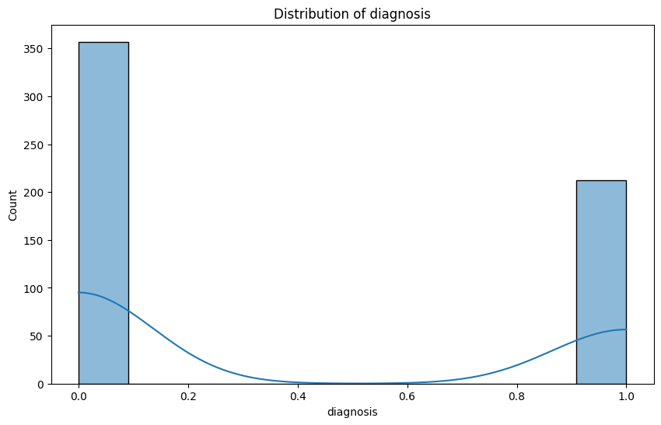

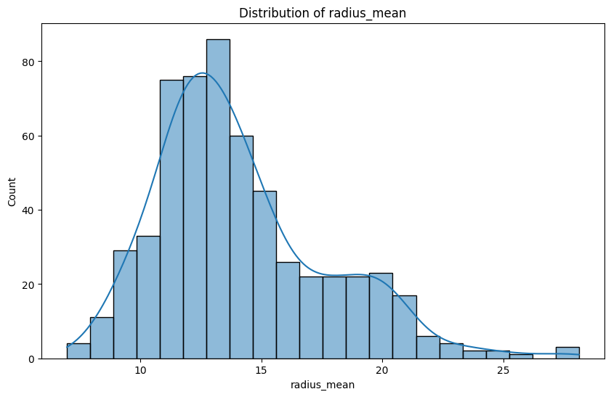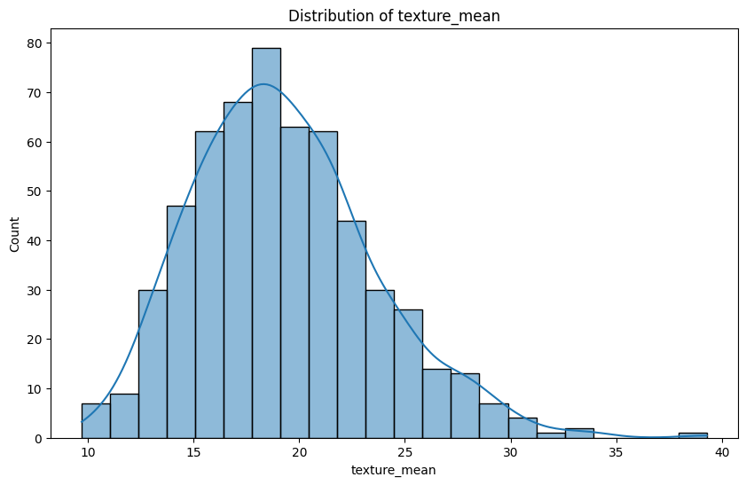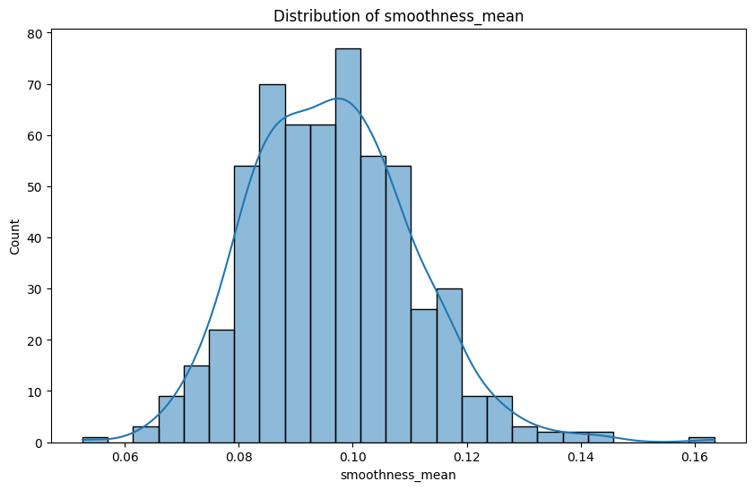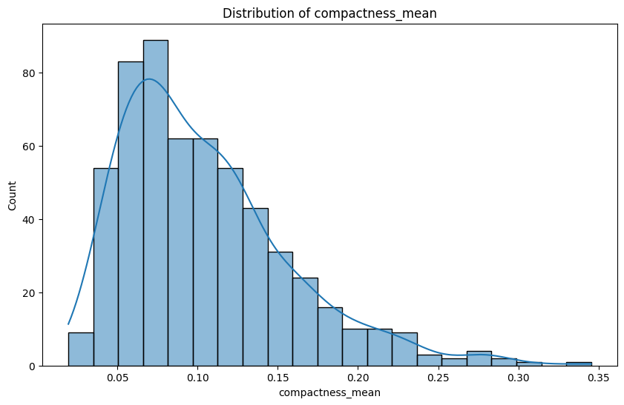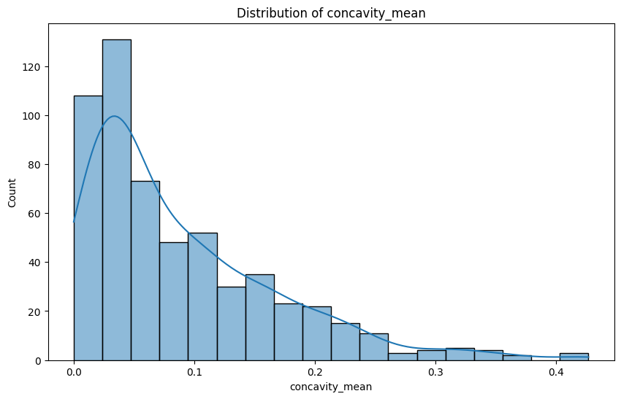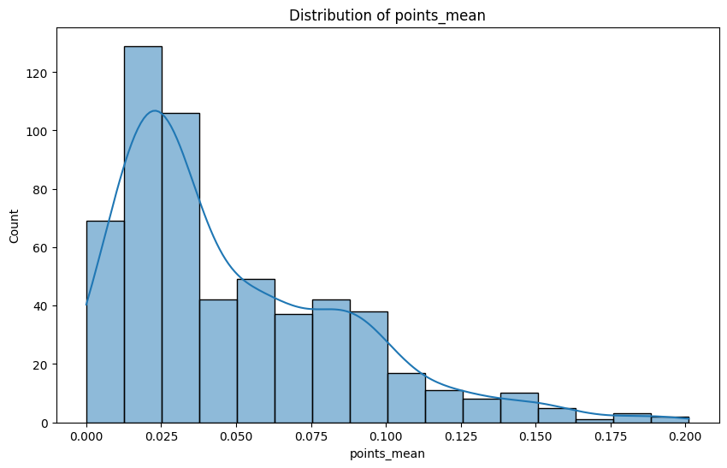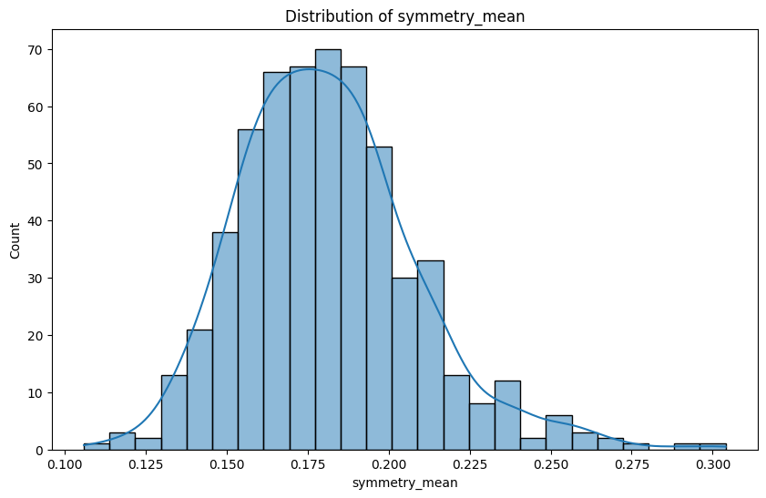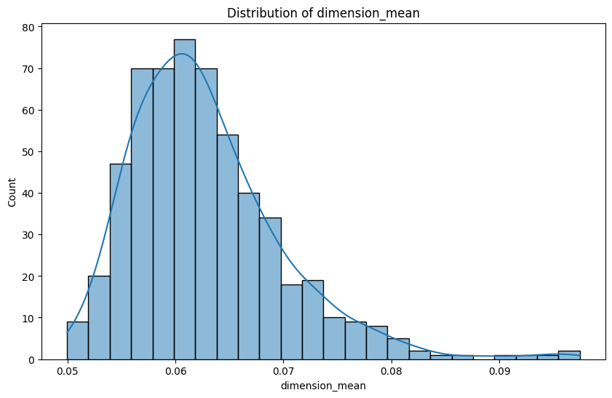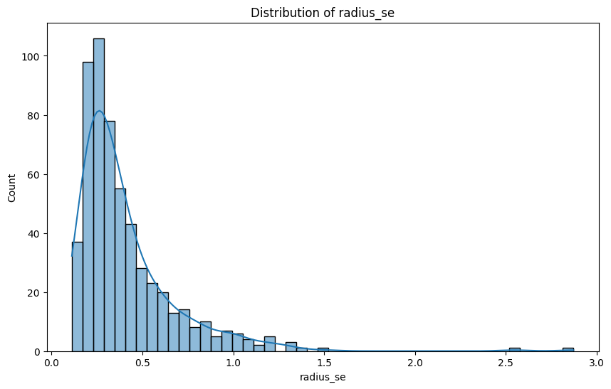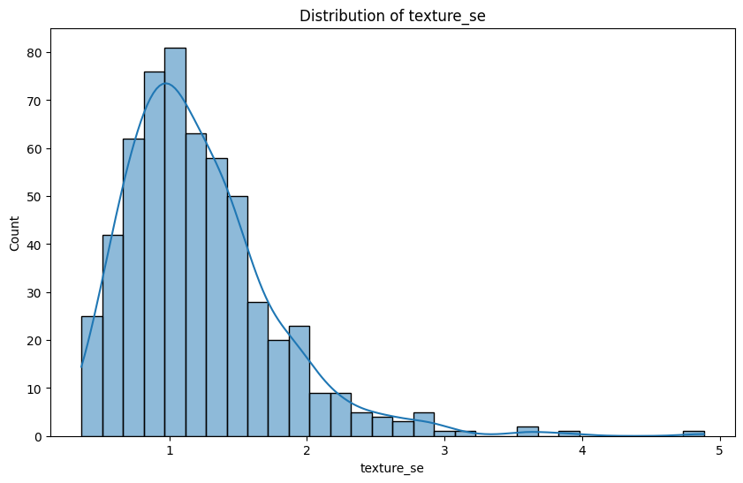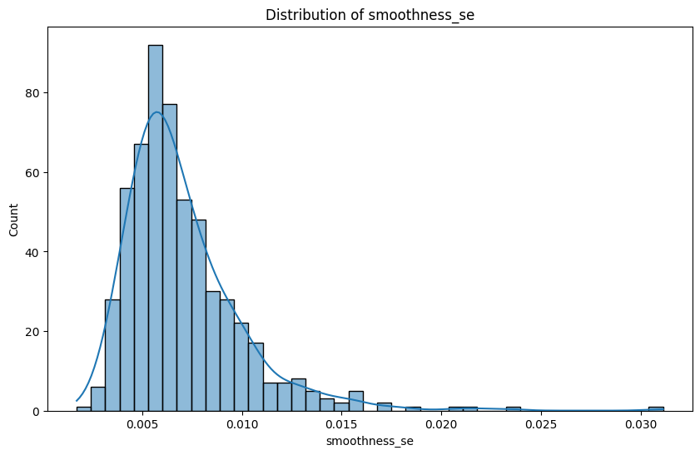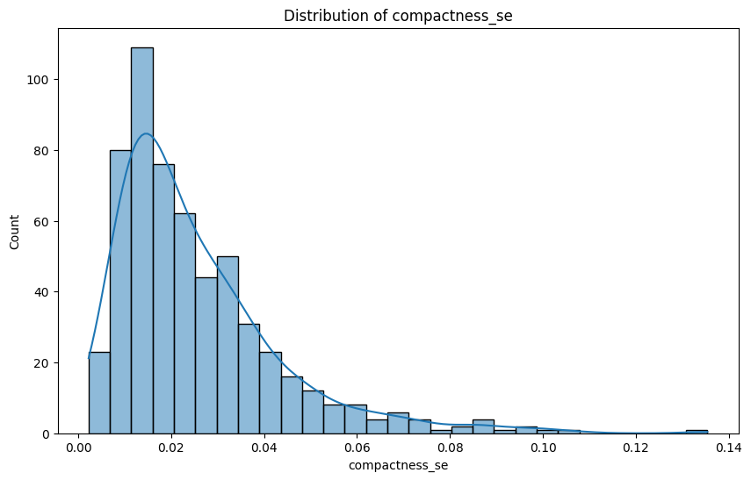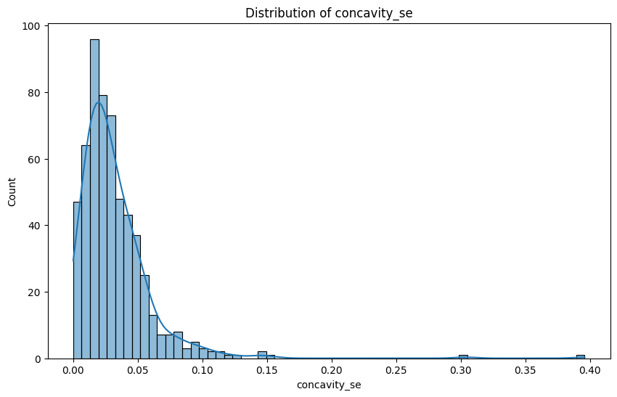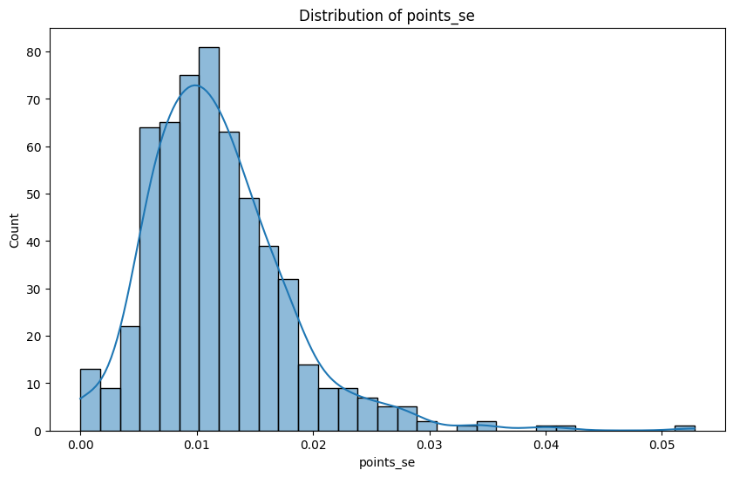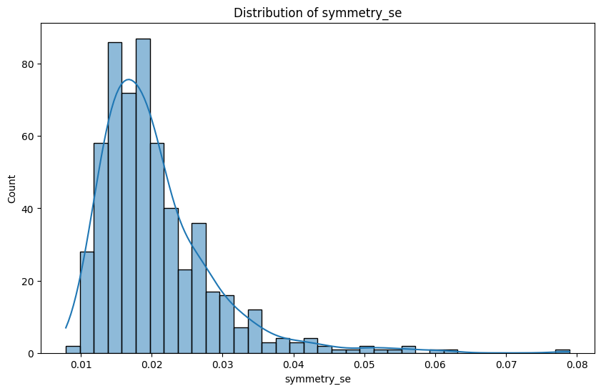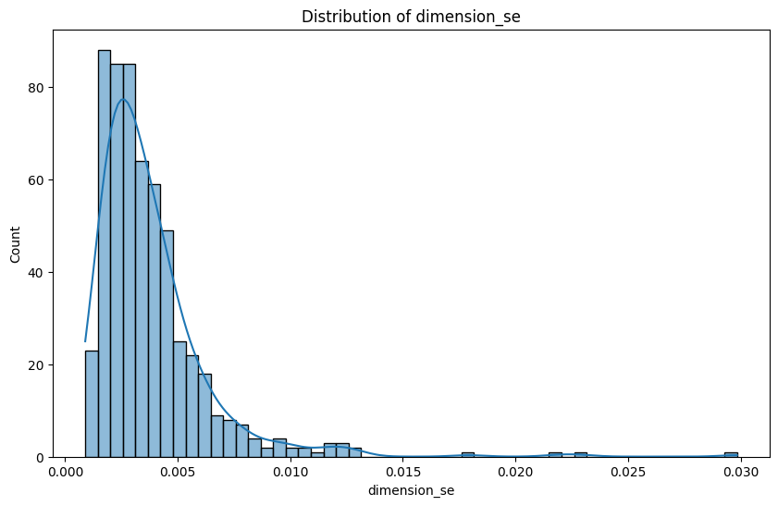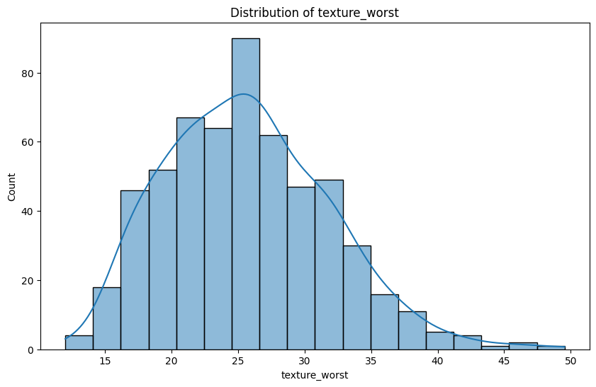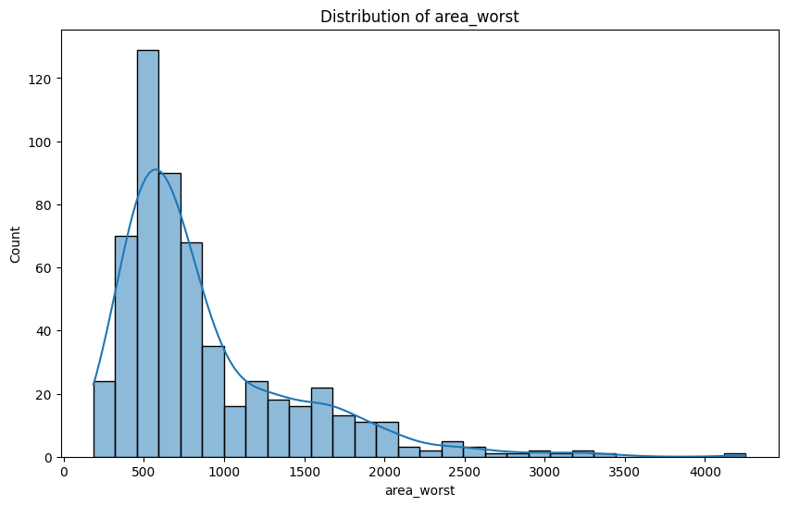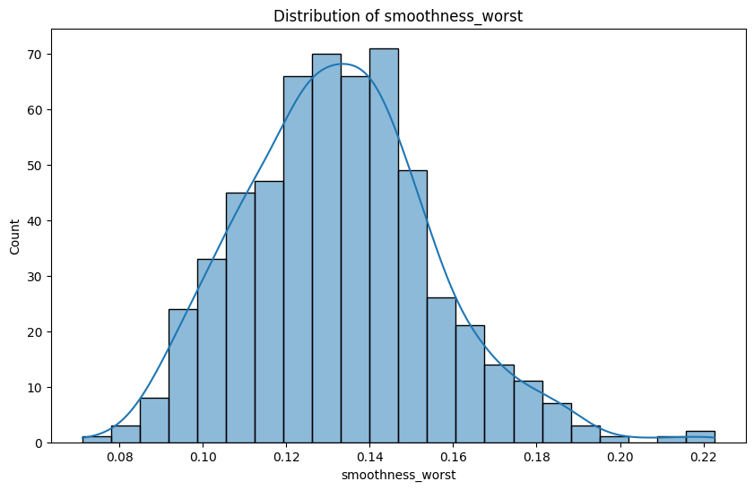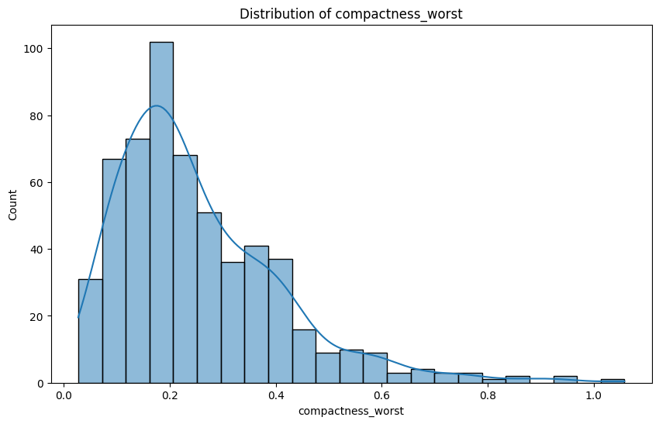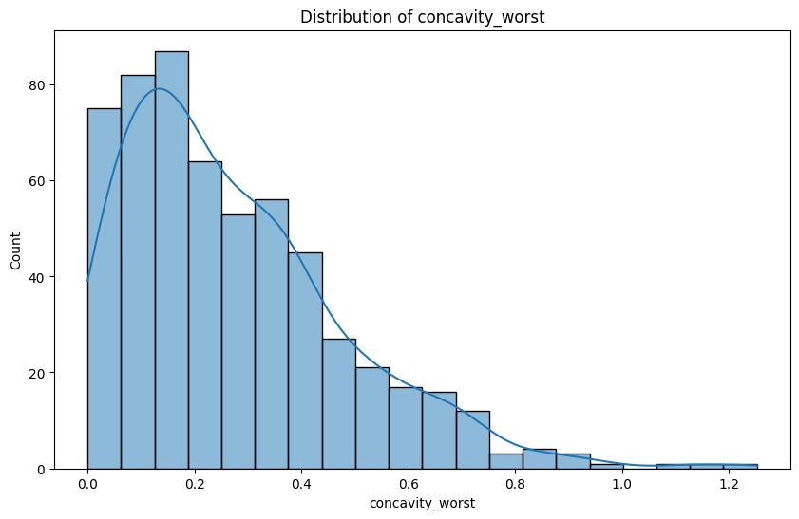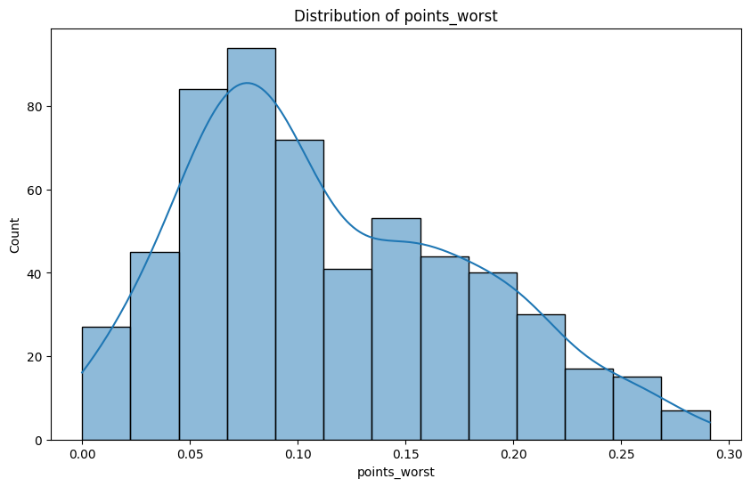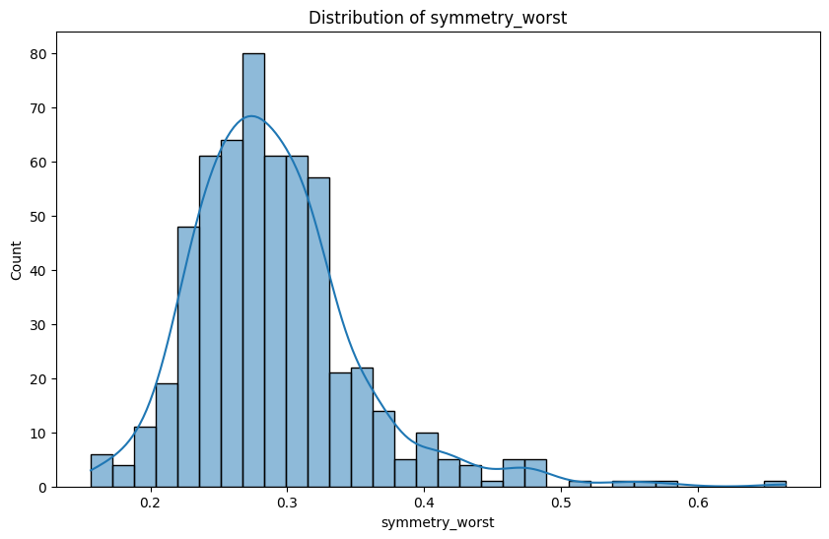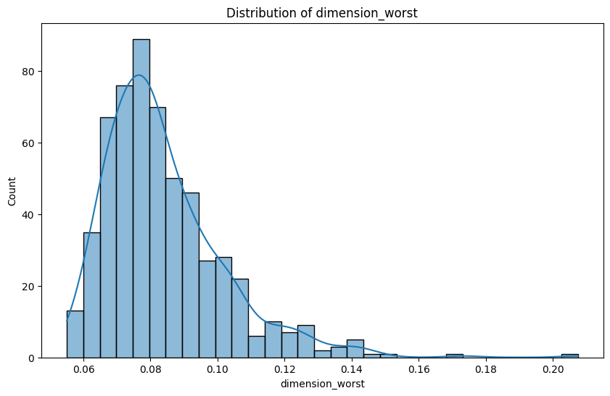

# Appendix D

# Pair Plot/ Scatter Plot of Dataset



**Appendix E**

**Timeline and Milestones**

|  |  |  |  |
| --- | --- | --- | --- |
| **Milestone** | **Duration** | **Projected Start Date** | **Projected End Date** |
| Analyze and clean dataset (Objective 1.1.1) | 2 days | 02-03-2025 | 02-05-2025 |
| Performance comparison (Objective 1.1.2) | 1 day | 02-05-2025 | 02-05-2025 |
| Implement best model, *Logistic Regression* (Objective 1.2.1) | 3 days | 02-06-2025 | 02-09-2025 |
| Summary document on logistic regression choice (1.2.2) | 1 day | 02-09-2025 | 02-10-2025 |
| Validate results (Objective 1.3.1) | 2 days | 02-10-2025 | 02-12-2025 |
| Final report documenting project (Objective 1.3.2) | 2 days | 02-12-2025 | 02-14-2025 |
| Develop machine learning pipeline (Objective 1.4.2) | 4 days | 02-14-2025 | 02-18-2025 |
| Documentation for ML pipeline (Objective 1.4.2) | 2 days | 02-18-2025 | 02-20-2025 |
| Demonstration of pipeline’s predictive ability (Objective 1.4.3) | 1 day | 02-20-2025 | 02-24-2025 |